ASSIGNMENT - 10.1
Name : MAMIDALA ANIRUDH KUMAR
Roll: 2303A53033
Batch : 46

Task 1 – Syntax and Logic Errors
You are a Python code reviewer.
Identify syntax and logical errors in the following code.
Fix the errors and provide corrected runnable code with explanation.

Code:
# Calculate average score of a student def calc_average(marks):
total = 0 for m in marks:
total += m average = total / len(marks) return avrage marks = [85, 90, 78, 92] print("Average Score is ", calc_average(marks)
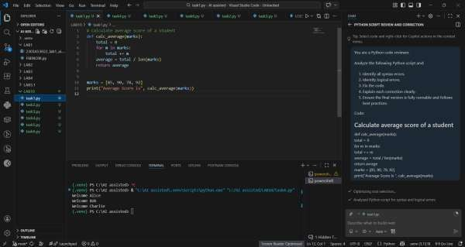

Explanation
- Fixed indentation errors.
- Corrected typo avrage → average.
- Closed missing parenthesis in print statement.
- Added empty list check to avoid ZeroDivisionError.
- Added docstring for better documentation.

Task 2 – PEP 8 Compliance

Task Prompt Used
Refactor the following code to strictly follow PEP 8 guidelines.
Improve formatting and naming without changing logic.

Code: def area_of_rect(L,B) : return L*B print(area_of_rect(10,20))
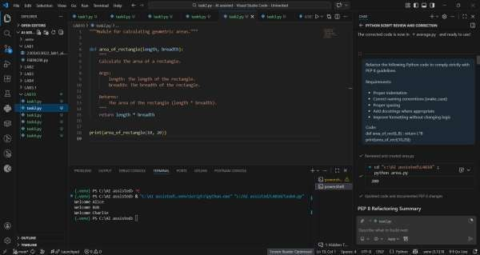

Explanation
- Used snake_case naming.
- Proper indentation and spacing.
- Added docstring.
- Improved readability.

Task 3 – Readability Enhancement

Task Prompt Used
Improve readability of the following code.
Use descriptive names, comments, and proper formatting.
Do not change logic.

Code:
def c(x,y):
return x*y/100 a=200 b=15
print(c(a,b))
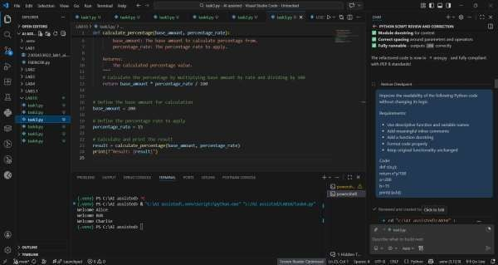

Explanation

- Function renamed for clarity.
- Meaningful variable names used.
- Added documentation.
- Proper formatting applied.

Task 4 – Refactoring for Maintainability

Task Prompt Used
Refactor the following code to remove repetition.
Create reusable function and improve maintainability.

Code:
students = ["Alice", "Bob", "Charlie"] print("Welcome", students[0]) print("Welcome",
students[1]) print("Welcome", students[2])
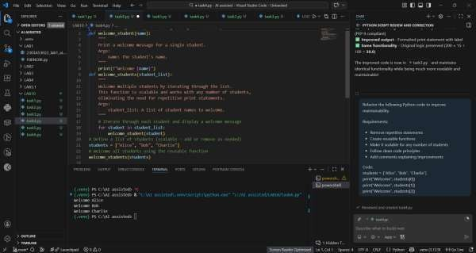

Explanation

- Removed repetitive statements.
- Created reusable function.
- Code is scalable.
- Improved maintainability.

Task 5 – Performance Optimization

Task Prompt Used
Optimize the following Python code for performance.
Use list comprehension or generator expressions.
Keep output same.

Code: nums = [i for i in range(1,1000000)] squares = [] for n in nums: squares.append(n**2) print(len(squares))
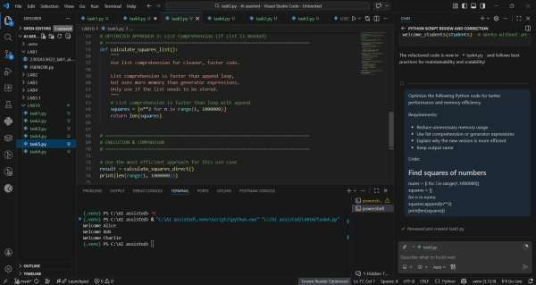

Explanation

- Removed unnecessary list creation.
- Used list comprehension (faster).
- Reduced memory usage.
- More Pythonic approach.

Task 6 – Complexity Reduction

Task Prompt Used
Simplify the following nested if-else logic.
Reduce complexity while maintaining same functionality.

Code:
def grade(score): if score >= 90: return "A" else: if score >= 80: return "B"
else: if score >= 70: return "C"
else: if score
>= 60: return "D"
else:
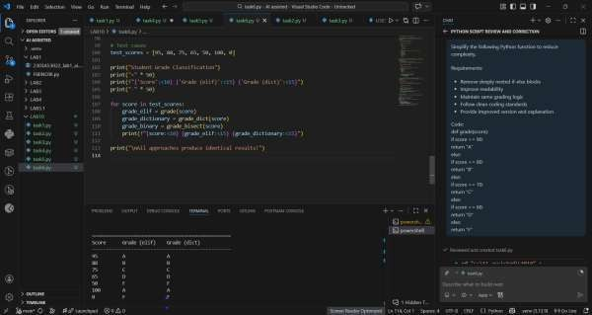

return "F"

Explanation

- Removed deeply nested conditions.
- Used elif for clarity.
- Improved readability and maintainability.

